**Texas Tech University**

**Department of Computer Science**

**Course:** Introduction to Artificial Intelligence **Group:** 1

**Student:** Felipe Chavarria Fernandez **Email:** fchavarriafernandez@gmail.com

**Date:** Wednesday, May 22, 2019

Table of Contents

Week 1 - Homework 1 1

Practice 1 1

Practice 2 2

Practice 3 2

Practice 4 3

Practice 5 3

Practice 6 6

# Week 1 - Homework 1

## Practice 1

We start by creating two arrays, ‘x’ and ‘y’ then we create a for loop that iterates over 100 numbers, for each number we append that number to array ‘x’ and also append the result of x[i]*3+5 to ‘y’ array.

Finally, we print ‘y’:

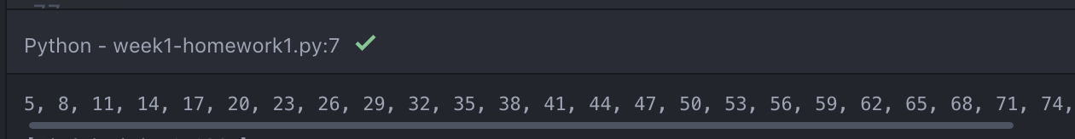

…



## Practice 2

We create 3 arrays ‘x,’ ‘y’ and ‘yr’, we create a loop form -10 to 10 and we append each number to ‘x’ array, we create a second array that iterates over all values in ‘x’, in it we append the result from 3*x[j]+5 to ‘y’ array and the same result to ‘yr’ array but we add to each value a random number from -5 to 5.

We then plot ‘y’ and ‘yr’:



## Practice 3

We start creating an array ‘l’ with the following numbers in it: 1 ,2, 3, 3, 1, 2, 2, 3, 1.

Then reshape that ‘l’ to an array ‘x’ that numpy can use, that array we then reshape it to a 3x3 matrix.

We then use np.linalg.inv(x) to calculate the inverse matrix of ‘x’ which w denote as ‘y’ and finally we multiply matrices ‘x’ and ‘y’ to prove that the result is an identity matrix:



**Note**: *y @ x* didn’t work for me, had to use *np.matmul(y, x)* instead.

## Practice 4

We start creating a data frame called ‘df’ that reads file "PeriodicTable.csv", we then create a new column in the date frame 'mass-num ratio' which it has the date from each row with the following information df['atomic mass']/df['atomic number'], this for each row.

We then print the first 6 rows of the date frame:



## Practice 5

Start by creating a date frame that reads "craigslistVehicles.csv" from there create three separate histograms, year, odometer and price:





**Note**: *import matplotlib as plt* didn’t work for me, had to use *import matplotlib.pyplot as plt* instead.

## Practice 6

Start by creating a date frame that reads "craigslistVehicles.csv", we then create two scatter plots, ‘Price vs Year’ and ‘Price vs Odometer’





**Note**: *import matplotlib as plt* didn’t work for me, had to use *import matplotlib.pyplot as plt* instead.